### COS30015 IT Security

You will need:

A computer with internet access to CyberChef (https://gchq.github.io/CyberChef/)

### Lab 8 week 8

In this lab you will do some exercises about encryption algorithms**.** This lab is based on the **CyberChef** (<https://gchq.github.io/CyberChef/>)

### Part 1: Data format

The following exercises are designed to complete with CyberChef.   
The goal is to change data format with different operations. We have been given the following hint:

1. What is Base64?

*Base64 is a binary-to-text encoding scheme that represents binary data in an ASCII format.*

1. Choose “To Base64” as the operation method, and type “This is a secret!”. What is the output? （No keep to change the default setting of To Bas64）

*VGhpcyBpcyBhIHNlY3JldCE=*

1. With the same input, change the Alphabet standard setting to “BinHex”. What is the output?

*9'KTFb"TFb"K)(0PBh*PG#%*

1. Keep the operation and output above, what should we do to recover and output the aforementioned input “This is a secret!” ?

*Change the operation from ‘To Base64’ to ‘From Base64’ and then change the alphabet standard setting from standard to BinHex*

1. Remove all the operations, choose the “From Base64” operation. Input “aGVsbG8=”, what is the output?

*hello*

1. Change the Alphabet parameter from “Standard” to “URL safe”. Does the output change? Why?

*No, because it’s basically the same*

1. Now you have tried some operations on CyberChef. Can you describe how to use cyberchef?

*Cyberchef is easy to use, you just pick the operation you want to use and it’s pretty much a straightforward approach after that. There’s an input field, and an output. You can type in some words or codes based on the operation you chose. It’s basically a google translate for machine.*

### Part 2: Hashing.

Now that we can review the concept of Hashing, and try some data format operation about hashing on platform CyberChef.

**The goal is to have an understanding and some exercises about Hashing using CyberChef.**

1. What is Hashing?

*Hashing is a process of transforming input data (such as text, files, or any kind of data) into a fixed-size string of characters, typically a hash code, using a mathematical algorithm.*

1. Choose “MD5” as the Hashing operation, and type “hello world”. What is the output?

*5eb63bbbe01eeed093cb22bb8f5acdc3*

1. Can we recover the output of MD5 hashing?

*MD5 is basically a one-way operation which means it’ll be impossible to try and get the original message.*

1. Choose “SHA0” as the Hashing operation, and type “hello world”. What is the output?

*9fce82c34887c1953b40b3a2883e18850c4fa8a6*

1. If we change the “Rounds” parameter from “80” to “8”. Does the output change? What does it output?

*Yes it does, e4f674479caaf7ed2a694b51bfbdcd22c86208d0*

### Part 3: Encryption and Decryption.

Now that we can review the concept of Encrption and Decryption, and try some data format operation about hashing on platform CyberChef.

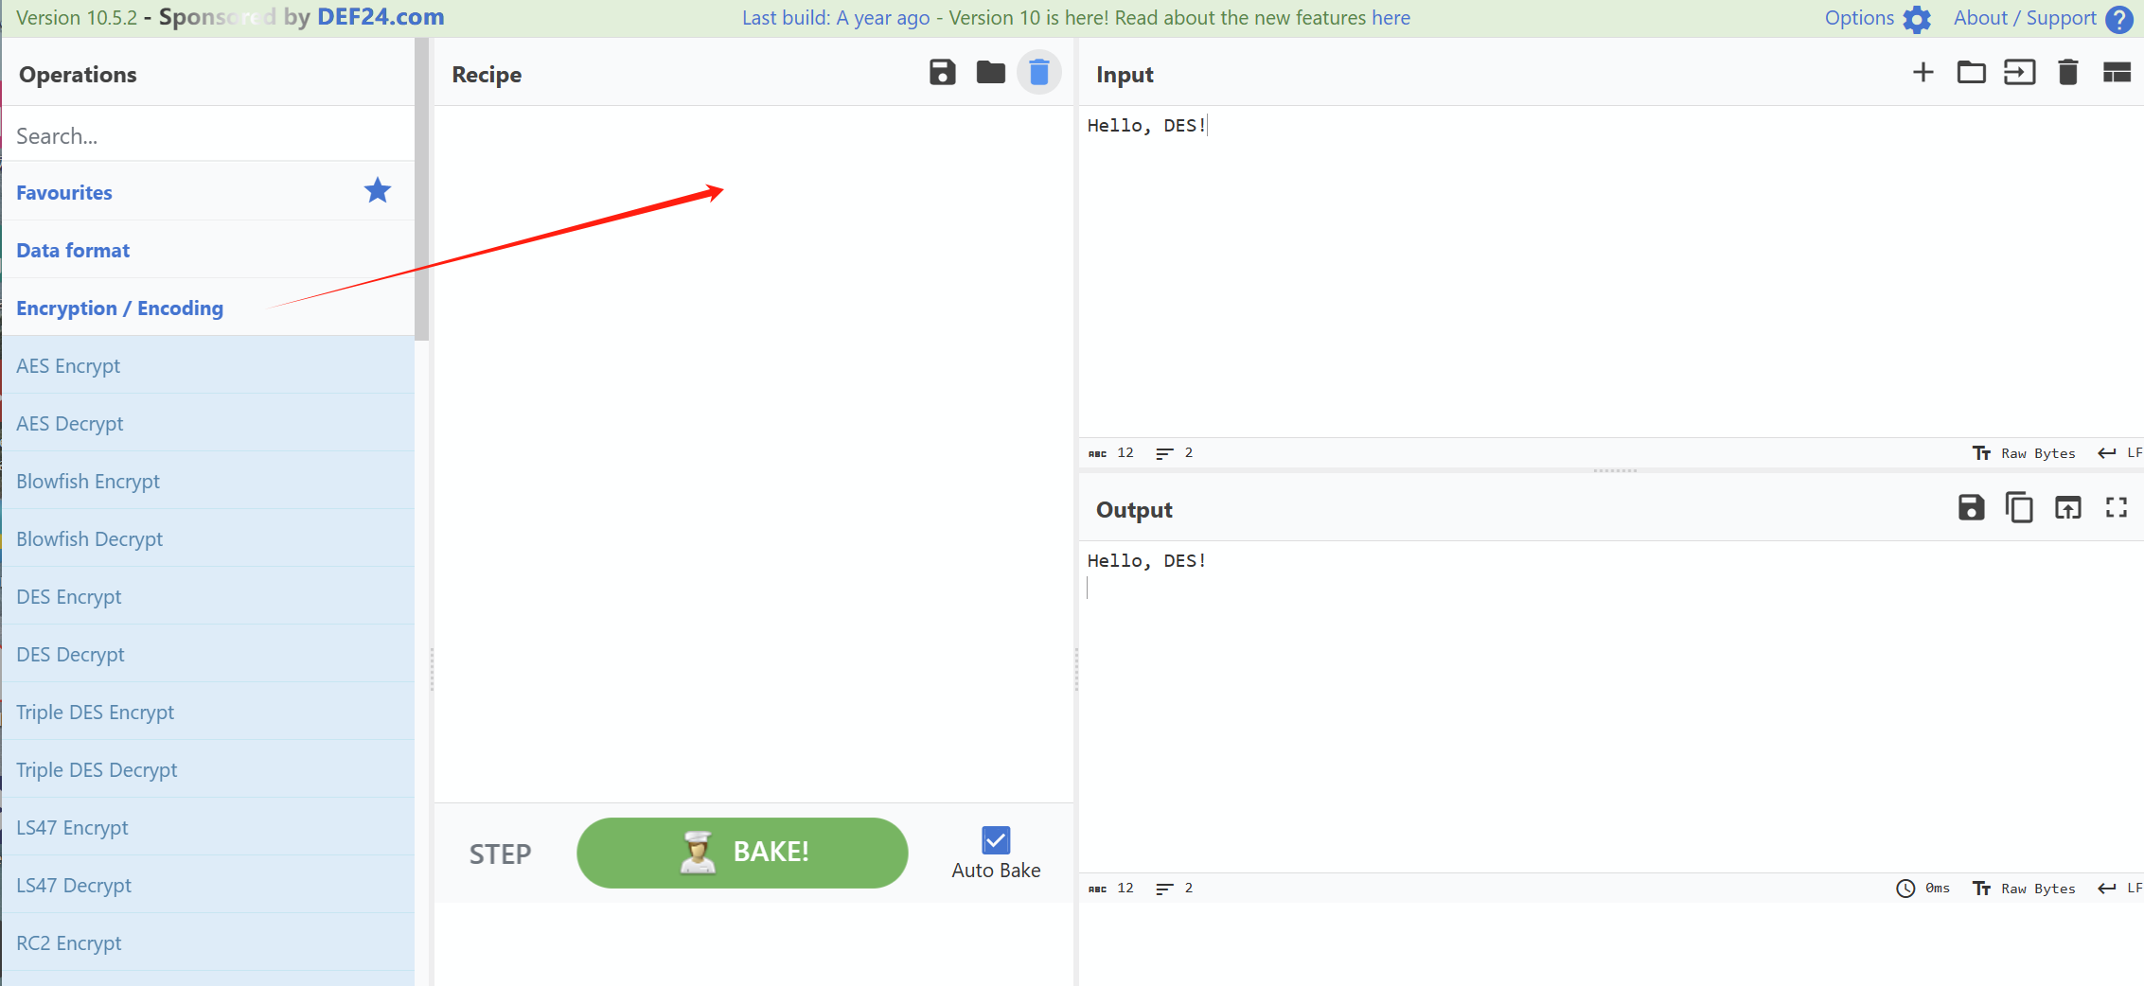

**The goal is to have an understanding and some exercises about Encryption and Decryption using CyberChef.**

1. Choose “AES Encrypt” as the encryption operation, and type “Hello, welcome to AES encryption!”. What is the output? (Hint: the value of Key length and IV length can be set as “9f74e669349afd7e076f94eaf7618d598e3d30c6ee561423dcc5909e44b6ee56” and “a7b8c6d5e4f3021234567890abcdef1”)

*8e6ac59e5fe677a7cd2f2b48a20ed1718c6061b44a8f81183212e9cf2a26c09bdab528e26e4ba6c27cbbbfcd6533ce92*

1. Does the output change if we select the type of IV length as “UTF8”?

*Yes it does. c865e9d5095c1032c6f4a7b29071d082a13c6c8a0f6cc9392a06261bcb83abfe8bd40915866b841ba42f41d13fb924b1*

1. How can we recover from the output?

*Just pick AES Decrypt from the operation*

1. Choose “DES Encrypt” as the encryption operation, and type “Hello, DES!”. What is the output? (Hint: the value of Key length and IV length can be set as “12345678” and “abcdefgh”. Both types are set as “UTF8”)

*00251b5f0276e470721bc679dd546f40*

1. Does the output change if we select the type of IV length as “LATIN1”?

*Nope, because the both present the ASCII character the same way. If there’s another character like é, then they would be different.*

1. How can we recover from the output?

*Same thing like the previous one, just change the operation to decrypt*